|  |  |
| --- | --- |
| OxTS Logo2 | Erco&Gener Modem  NTRIP Setup with RT |

|  |  |
| --- | --- |
| Date: | 140409 |
| Version: | 140409 |
| Author: | PA |
| Document owner: | Support |

List of contents

1. Things you will need 1

2. Process 1

3. Revision History 3

# Things you will need

* 5.5-32V Power supply
* NTRIP Modem
* SIM card
* SIM card details - APN user:password, SIM pin
* NTRIP provider service account
* NTRIP IP/URL and Port
* NTRIP user:password
* PC with RS232 port, or USB to Serial converter cable
* 15 way to 9 way serial cable from OxTS (14C0097A)
* Come2ascos software

<http://www.allsat.de/fileadmin/Dateien/Technik/Software/come2ascos/come2ascos_3.52.zip>

Putty software - <http://the.earth.li/~sgtatham/putty/latest/x86/putty.exe>

# Process

* Unbox
* Connect serial cable either directly or via USB to serial cable
* If using USB to serial converter cable, check the COM port through Control Panel > Device Manager > Ports

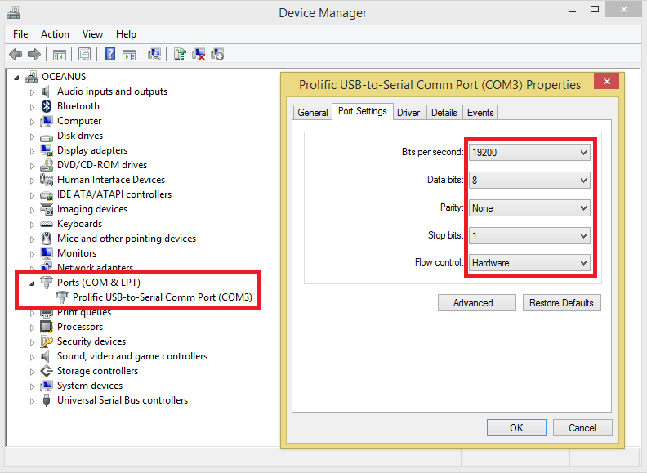

* Connect power cable
* Insert SIM card
* Connect modem to power
* Open come2ascos software
* Connect on correct Baud Rate

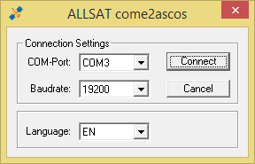

* Configure the unit in the following steps

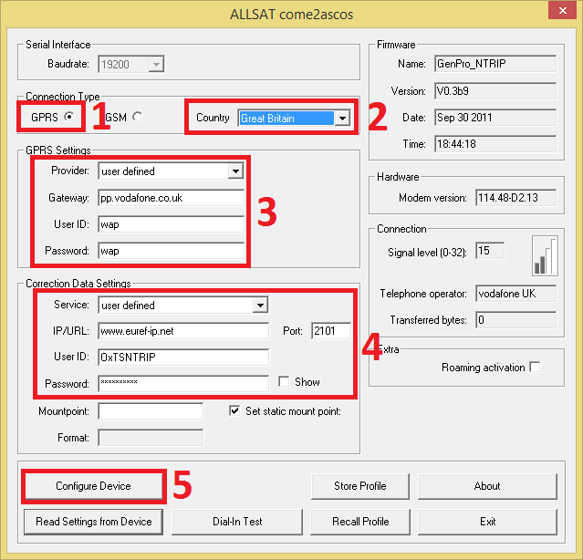

1. Set the modem to use GPRS
2. Set your country, this will change the drop down list of providers in the GPRS settings section
3. Choose a network provider or enter phone network info, APN, User and Password (this information can be found by searching "<phone network name> APN setup" in a search engine on the internet, depending on the SIM card being pay as you go, or contract, it may be different)
4. Select a predefined service if it is available or enter the NTRIP details provided by your NTRIP provider and your user ID and password
5. Commit the settings to the device

The device should now be ready to use.

# Configuring the RT to use NTRIP corrections

During the NAVconfig setup, there will be an option to enable NTRIP corrections. This is found on the "Options" tab under the "Differential".

To enable NTRIP:

* Select the correction format of your service, RTCM or RTCMv3
* Set baud rate to 19200
* Check the box to enable NTRIP corrections.

This will configure the RT to output NMEA GGA messages to the modem to tell the service where you are located.

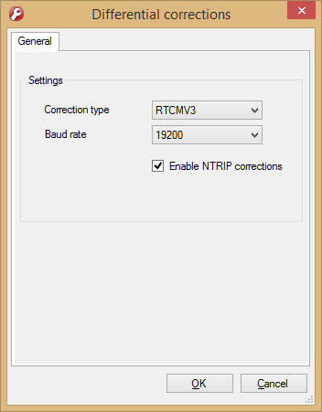

* Commit configuration to RT and wait for automatic reset

Opening Enginuity now, you should see the unit has rebooted and observing satellites. To check that the corrections are being received, check the "Diff Age" field at the bottom of the Performance window:

# Revision History

Table 1

|  |  |
| --- | --- |
| Revision | Changes |
|  |  |
|  |  |