|  |  |
| --- | --- |
| OxTS Logo2 | NTRIP setup guide |

|  |  |
| --- | --- |
| Version: | 140409 |
| Author: | Simon Nell |
| Confidentiality: | None |

List of contents

1. Equipment required 1

2. Method 2

2.1. Configure the Bluetooth RS232 serial adapter 2

2.2. Setting up the INS 2

2.3. NTRIP corrections via laptop 3

2.4. NTRIP corrections via smart phone 5

3. Revision History 9

# Equipment required

* 1x INS (RT/Inertial+/Survey+/xNAV) plus associated antennas and cables
* 1x 15-way to 9-way serial adapter cable
* 1x Bluetooth RS232 serial adapter
  + LM Technologies LM048 Bluetooth RS232 serial adapter has been used successfully

Figure : LM Technologies LM048 Bluetooth RS232 serial adapter

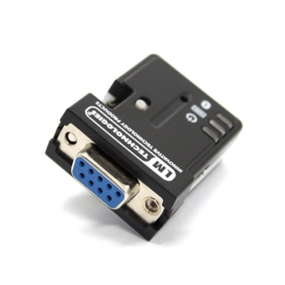

* 1x NTRIP client program
  + Lefebure NTRIP client is available as an mobile phone app on the Google Play store, or as an executable from <http://lefebure.com/software/ntripclient/>
* 1x mobile data link
  + Either Wi-Fi or mobile data link

# Method

## Configure the Bluetooth RS232 serial adapter

The screenshot and instructions given in this section are specific to the LM149 Configuration Tool. Different Bluetooth RS232 serial adapters may require different configuration.

Figure : LM149 Configuration Tool

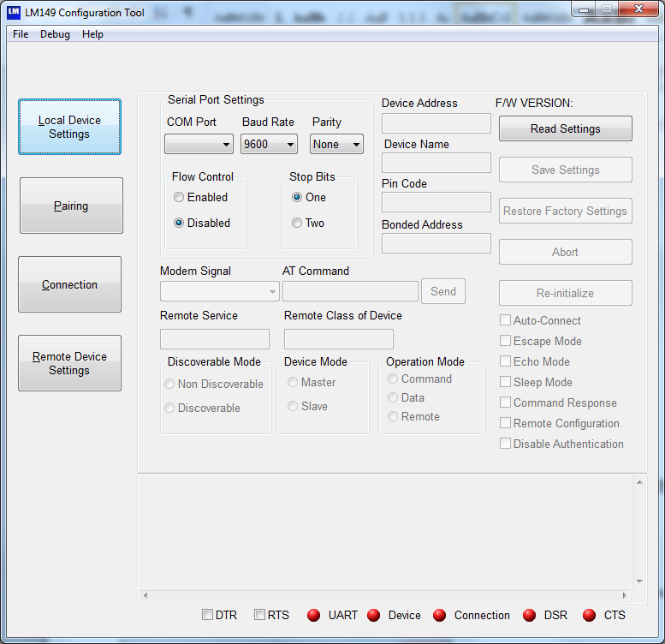

Connect the Bluetooth RS232 serial adapter to a serial port. Select the COM port in the software and select Read Settings. Typically a baud rate of 9600 bit/s is used with differential corrections. Also make a note of the device name and pin code. All other settings can be left as default.

## Setting up the INS

1. Set up the INS in your vehicle
2. In NAVconfig, on the Options page in the Differential window, select your correction type and tick the box to enable NTRIP corrections (see Figure 3).

Figure : NAVconfig Differential window

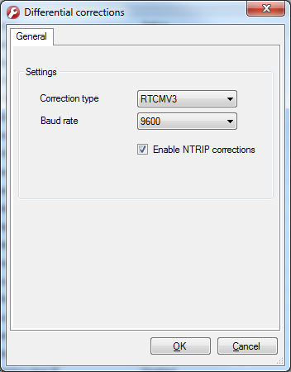

1. Connect your 15-way to 9-way serial adapter cable to the J3 Radio/Differential port of your INS.
2. Connect the Bluetooth serial adapter to the other end of the 15-way to 9-way cable. It may be necessary to power the Bluetooth serial adapter via USB if power isn't supplied by the cable.

## NTRIP corrections via laptop

Any instructions and screenshots in this section are specific to the Lefebure NTRIP Client executable program. This process requires a laptop with Bluetooth capability and a Wi-Fi or cellular data link.

1. Pair the laptop with the Bluetooth RS232 serial adaptor over Bluetooth.
2. Launch the NTRIP client (see Figure 4).

Figure 4: Lefebure NTRIP Client executable program

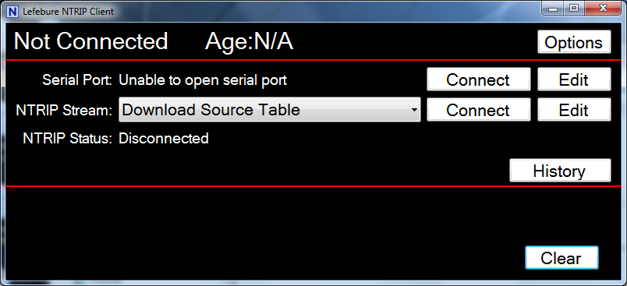

1. Select the Edit Serial Port option (see Figure 5), and select the virtual serial port which the Bluetooth RS232 serial adapter is using.
2. Ensure that the correct baud rate is set for the serial port. This must match the baud rate of the Bluetooth RS232 serial adapter and the differential port of the RT. The default baud rate for these is 9600 bit/s.

Figure 5: Serial port settings

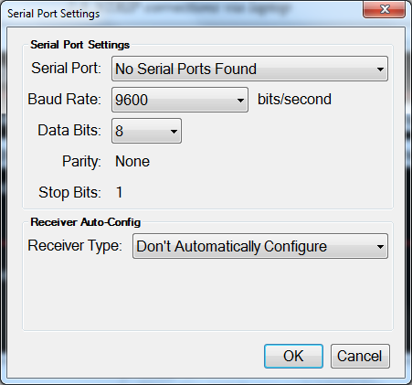

1. Click OK, then select the Edit NTRIP Stream option (see Figure 6).

Figure 6: NTRIP settings

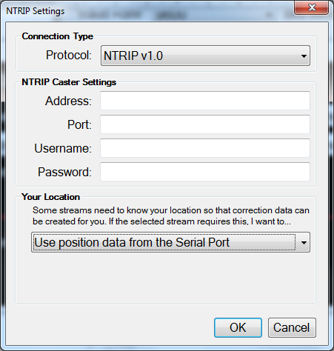

1. Select NTRIP v1.0 protocol and use position data from serial port.
2. Enter the NTRIP caster settings which usually must be requested from the NTRIP service provider.
3. Click OK.
4. In the NTRIP Stream drop-down menu, select Download Source Table. This will contact the NTRIP caster and download a list of available differential streams.
5. Click the Connect button for the serial port, then Connect for the NTRIP stream.
6. When the source table has populated, select a differential stream and click the Connect button for NTRIP stream again.
7. Your system should now be receiving differential corrections.

## NTRIP corrections via smart phone

Any instructions and screenshots in this section are specific to the Lefebure NTRIP Client Android smartphone app. This process requires a smartphone with Bluetooth capability and a Wi-Fi or cellular data link.

1. Pair the phone with the Bluetooth RS232 serial adaptor over Bluetooth.
2. Launch the NTRIP client app (see Figure 7).

Figure : Lefebure NTRIP Client app

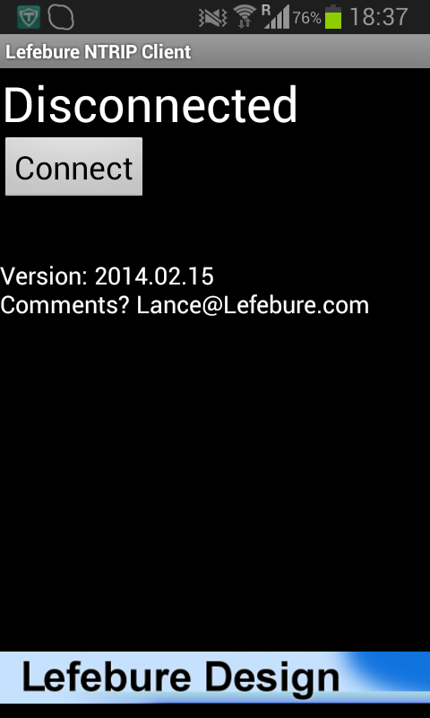

1. Press the menu button of your phone then select Options. You will see the menu shown in Figure 8.

Figure : options menu

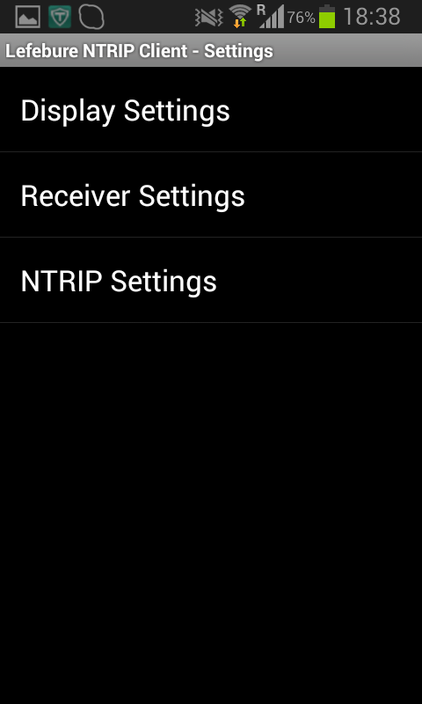

1. Select Receiver Settings (see Figure 9), and set the Receiver Connection to External via Bluetooth, and if not done so already, pair your phone with the Bluetooth RS232 serial converter.

Figure : receiver settings

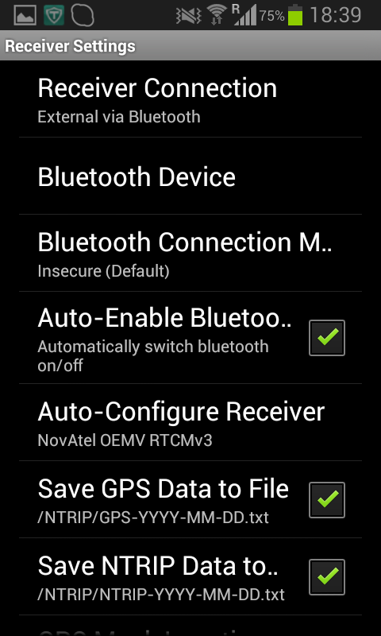

1. Return to the Options menu, then select NTRIP settings (see Figure 10).

Figure : NTRIP settings

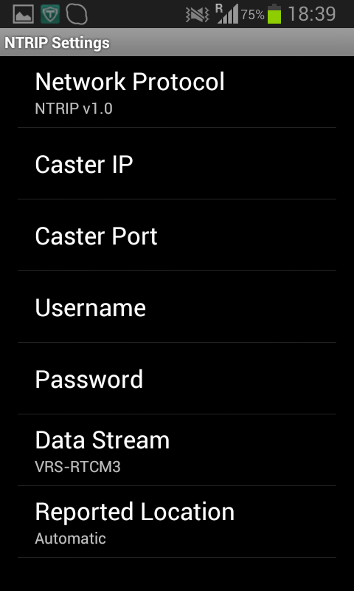

1. Set the Network Protocol to NTRIP v1.0.
2. Enter the Caster IP, Caster Port, Username and Password. This must usually be requested from the NTRIP service provider.
3. Under Data Stream, select Download Source Table. This will contact the NTRIP caster and download a list of available differential streams.
4. Set Reported Location to Automatic.
5. Return to front page of the app (see Figure 7) and click Connect.
6. This will download a new list of available differential streams.
7. Return to the NTRIP settings page (see Figure 10) and select a data stream.
8. Return to front page of the app (see Figure 7) and click Connect.
9. Your system should now be receiving differential corrections.

# Revision History

Table 1

|  |  |
| --- | --- |
| Revision | Changes |
| 140426 | Initial draft |