|  |  |
| --- | --- |
| OxTS Logo2 | Support Guide |

|  |  |
| --- | --- |
| Subtitle: | How to configure a GPS-Base as an NTRIP server |
| Date: | 29/04/2015 |
| Version: | Draft |
| Author: | Simon Nell |
| Document owner: | Support Manager |
| Confidentiality: | None |

List of contents

1. Introduction 1

2. Equipment required 1

3. Method 1

3.1. Setting the baud rate on the GPS-Base 1

3.2. Configuring the GPS-Base 5

3.3. Configuring the laptop 5

3.4. Setting up the NTRIP caster 6

3.5. Connecting to the NTRIP caster 8

4. Revision History 8

# Introduction

This support guide describes to process to configure a GPS-Base as an NTRIP server.

# Equipment required

* GPS-Base
* GPS-Base power cable
* GNSS antenna with cable
* Null modem cable
* USB/serial adapter
* USB A to mini B cable
* Laptop
* Ethernet cable
* NTRIP caster software (available from this [download link](http://lefebure.com/software/ntripcaster/NTRIPCaster.exe))
* NovAtel config software (available from this [download link](http://lefebure.com/software/novatelconfig/20150330/NovAtelConfig.exe))

# Method

## Setting the baud rate on the GPS-Base

1. Connect to the GPS-Base by USB and power it on.
2. Open the NovAtel config software.
3. Select the relevant COM port (which will be shown as NovAtel USB Virtual Serial Port), select baud rate 9600 and click Connect

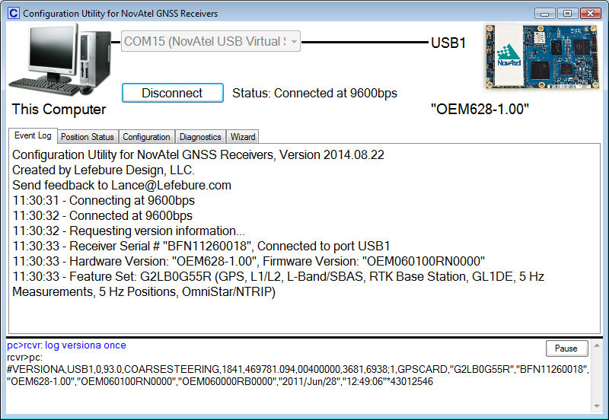

Figure : NovAtel config software connected

1. Select the Configuration tab and click the option 'Type a Command'

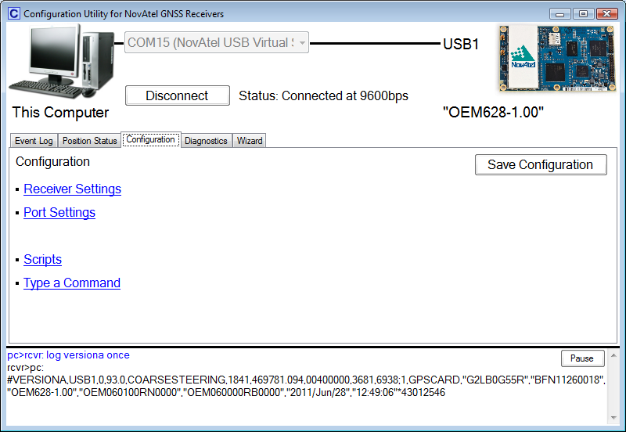

Figure : NovAtel config software Configuration tab

1. Enter the following command:

COM COM2,115200,N,8,1,N,OFF,OFF

1. Click the 'Send Commands' button
2. Click the 'Configuration' option, as highlighted in red below.

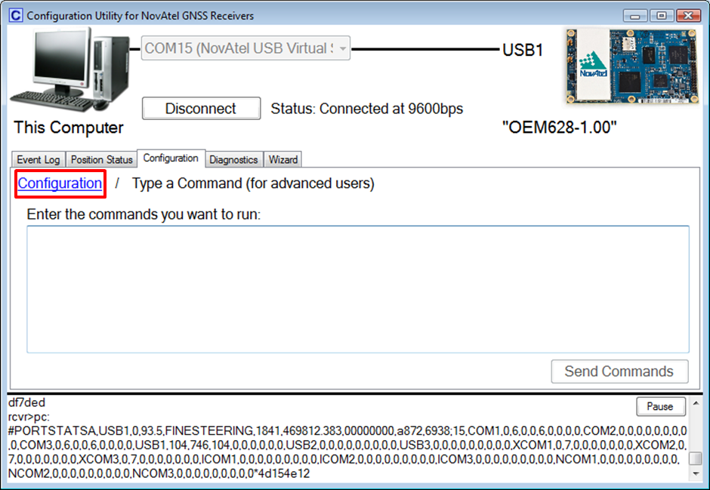

Figure : 'Configuration' option in NovAtel config software

1. Click 'COM2', as highlighted in red below.

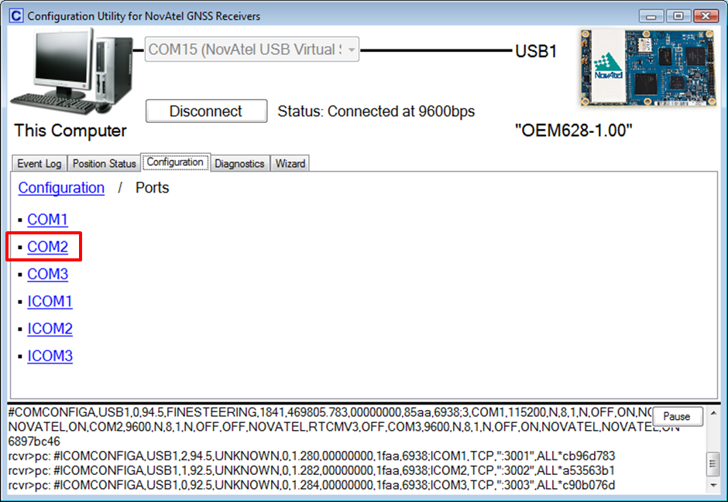

Figure : 'COM2' option in NovAtel config software

1. The next page will show you the baud rate. If the baud rate has not updated, it will show 'Baud Rate (9600,8,N,1, Break Disabled)'. If it has updated correctly, it will show 'Baud Rate (115200,8,N,1, Break Disabled)'
2. If you wish to save this configuration, then the following command can be sent to the GPS-Base (on the same page as shown in Figure 3):

SAVECONFIG

1. If the SAVECONFIG command is not sent then the unit will return the baud rate of COM2 to 9600 after the next power cycle.

## Configuring the GPS-Base

1. Configure the GPS-Base to use your desired correction format
2. Set or average the position of the GPS-Base
3. Connect a null modem cable to the COM2 connector of the GPS-Base
4. Connect the other end of the null modem cable to your computer (using a USB/serial adapter if necessary)

## Configuring the laptop

1. Open Device Manager (searchable from the Start menu)
2. Select 'Ports (COM & LPT)', right-click the relevant serial port and click Properties

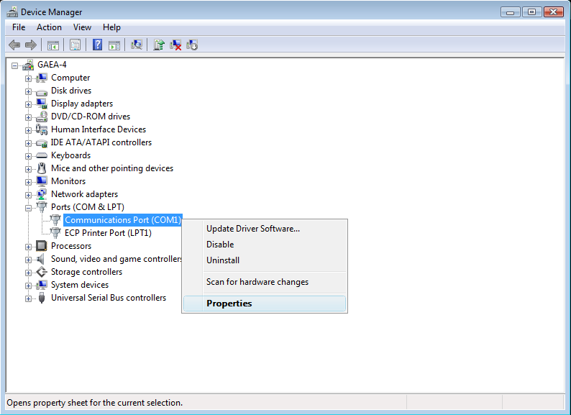

Figure : Device Manager

1. In the Communications Port window, click the Port Settings tab and set a baud rate of 115200 bps

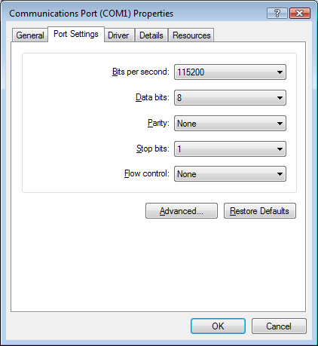

Figure : COM port settings

1. Connect the computer, via Ethernet, to an externally facing port with a unique IP address. This will allow the NTRIP corrections to be broadcast over the Internet
2. Open the Network and Sharing Center (searchable from the Start menu)
3. Click on your Local Area Connection
4. Click Properties
5. Double-click Internet Protocol Version 4 (TCP/IPv4)
6. Select 'Use the following IP address:' and enter the IP address, subnet mask, default gateway and DNS server addresses of your externally facing port.
7. Click OK to save the IP address configuration

## Setting up the NTRIP caster

1. Open the NTRIP caster software
2. Select the 'Mount Points' tab
3. Enter a name for this caster, and fill in the rest of the details including an approximate lat/lon position

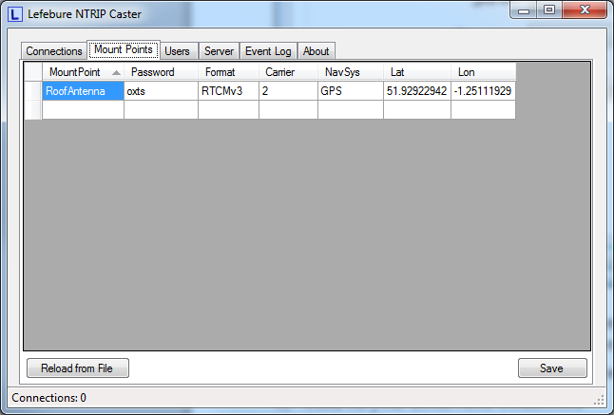

Figure : NTRIP caster, Mount Points

1. Select the 'Users' tab. Add at least 1 user name. You can add as many user names as you like as long as each one is unique. A user name can only be used by one person at a time

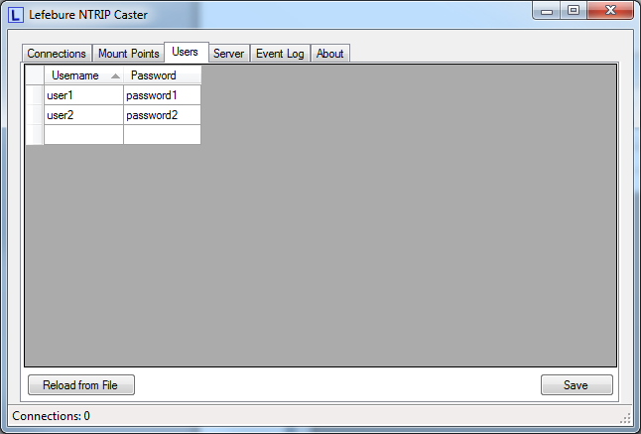

Figure : NTRIP caster, Users

1. Select the 'Server' tab. Enter the name of your Mount Point (as shown in Figure 7), select your serial port, 115200 baud rate, and click Connect

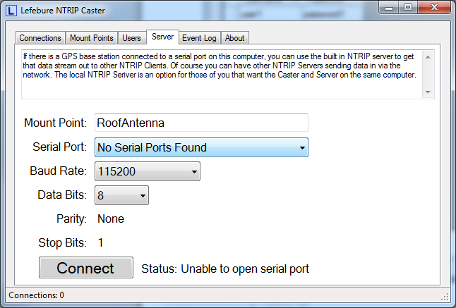

Figure : NTRIP caster, Server

1. The NTRIP caster is now outputting data

## Connecting to the NTRIP caster

To connect to an NTRIP caster you will need an NTRIP client. An NTRIP client setup guide is available from [support@oxts.com](mailto:support@oxts.com).

To connect to a caster you will need to following information:

* Caster IP address. This will be the IP address the computer was configured with in Section 3.3
* Caster port number. This will most likely be port 5000
* User name. This is configured in the NTRIP caster software
* Password. This is configured in the NTRIP caster software

# Revision History

Table

|  |  |
| --- | --- |
| Revision | Changes |
| 150422 | Initial draft |
| 150429 | Final draft |