Digital Certificate installer problem workaround

Right click the installer and select properties
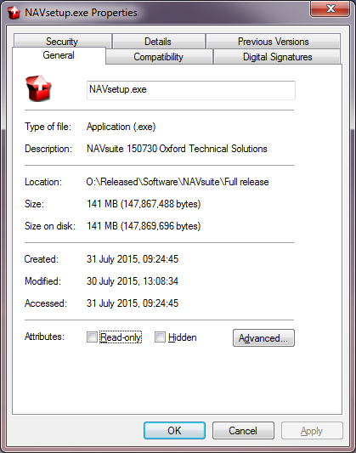

Click the Digital Signatures tab and click on the “Oxford Technical Solutions Ltd” entry in the Signature list.
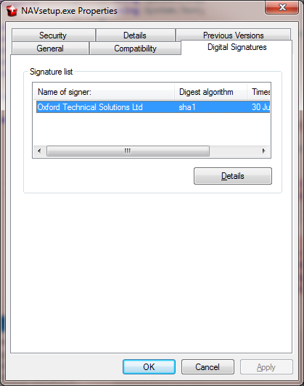
Press the details button.

This will display the Digital Signature Details screen
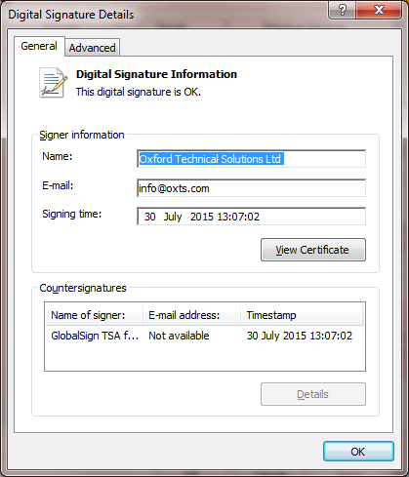
Click the view certificate button.

Press the Install certificate button on the Certificate screen
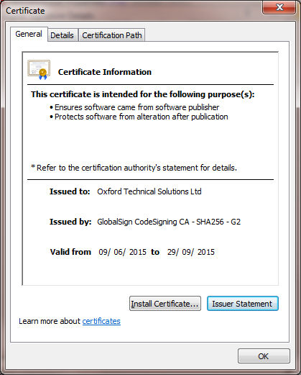

Follow the wizard steps, using all the default options and press the Finish button.
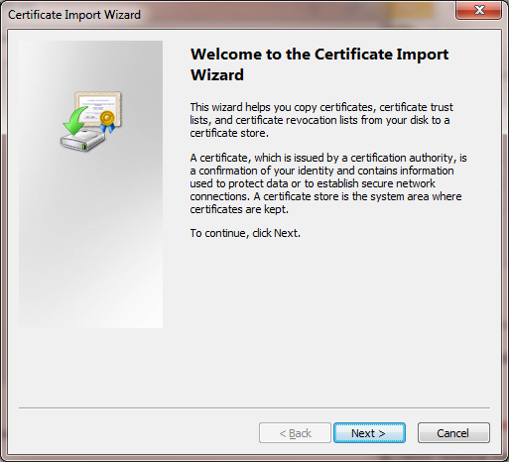
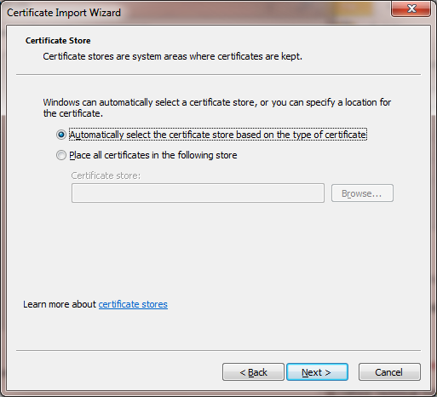
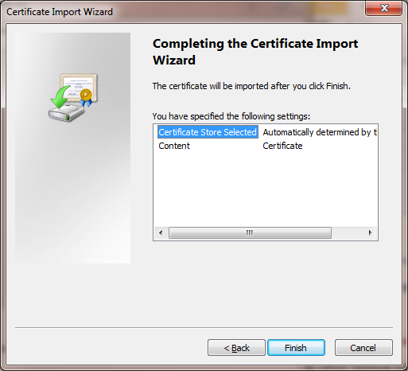

Once the certificate has installed, double click the installer to attempt the install process again.

Removing the need to be connected to the internet

Copy the file “Root-R3.crt” to the machine NAVsuite is to be installed on.

Right click the file “Root-R3.crt” and select “install certificate” option.

Click “Next” on the Certificate Import Wizard 1st wizard page.

Select the “Place all certificates in the following store option”

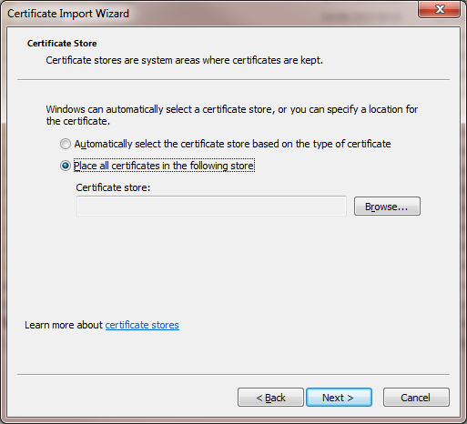

And press the browse button.

From the “Select Certificate Store” screen, select the “Trusted Root Certificate Authorities” folder and press the “OK” button.
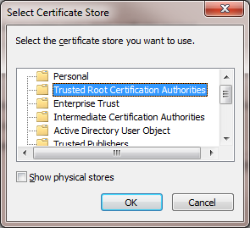

Press the “Next” button on the “Certificate Import Wizard” screen and agree to the Security Warning
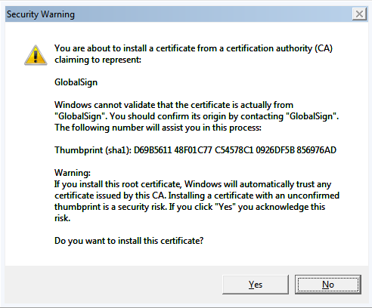

Install NAVsuite as normal.

